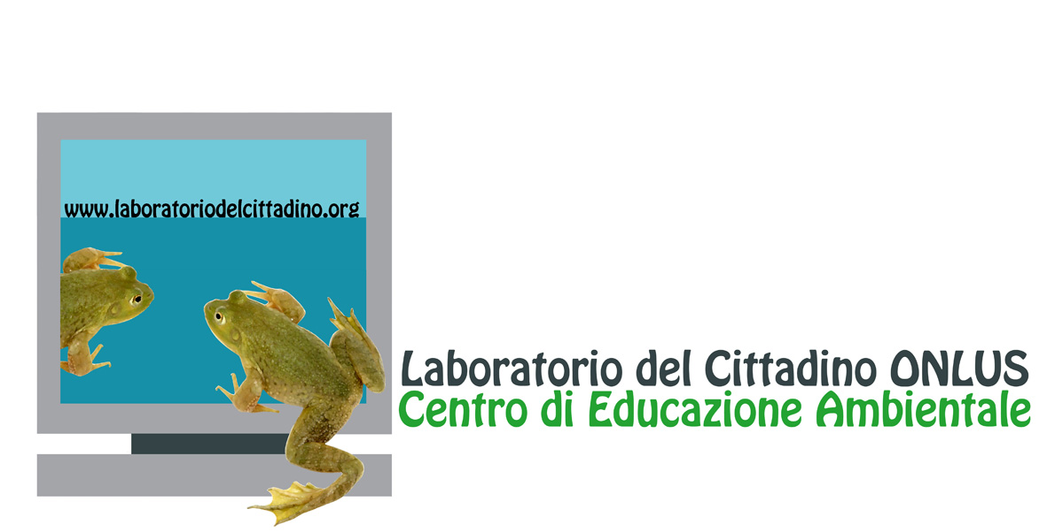
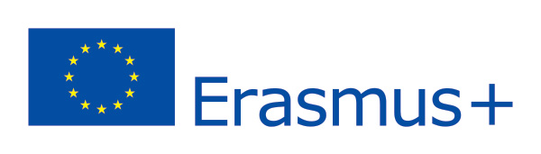

Pre-inscription form

ERASMUS+ AK1

TRAINING COURSE:

☐ “Grand Tour in Europe: Creativity, Innovation, Active Citizenship and Intercultural Dialogue”

☐ “Europe between Mythology, Modernity and Multiculturalism”

- NAME OF THE INSTITUTION/ORGANISATION/SCHOOL:
______________________________________________________________________________

- ADDRESS OF THE INSTITUTION/ORGANISATION/SCHOOL:
______________________________________________________________________________

NAME OF PARTICIPANTS | PLACE OF TRAINING | DATE | LANGUAGE  ENG/FRA

These participants are officially registered in the sessions mentioned above

Contact person:
Name and Surname:
Mail:
Mobile number:

Participants:
Name and Surname:
Mail:
Mobile number:
Mariella Morbidelli

Responsible for the training
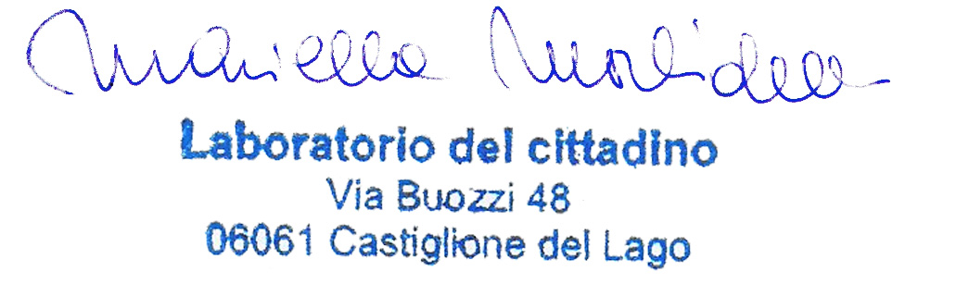

Laboratorio del Cittadino ONLUS
C.F:80051670547
Via B. Buozzi 48 – 06061
Castiglione del Lago
Tel. +390759652651
labdelcittadino@libero.it

